# Shared Care Records summary

Shared Care Records summary 1

Executive Summary 2

Background Context 3

Stages of development 4

Suppliers 5

System architecture 6

Data and IG 7

Sharing for direct care is the most straightforward 7

Individual organisations are data controllers in most cases 8

Sharing requires data-sharing agreements between data controllers 8

Role based access across Shared Care Records have different approaches 9

User Experience 9

In context launch and viewing patient encounters in one system. 9

Showing encounters 10

Tailored view of patient information 12

Famine to feast 13

Access to records 14

Examples of Shared Care Records built on user-centred design principles 14

Public perception and consultation 15

Shared Care Records are already making a difference 15

Challenges with Shared Care Records in the context of Patient Encounter History 16

Data gaps 16

Maturity and Digital inequality 17

Awareness and adoption of the program 17

Encounter information is dispersed across multiple screens/tabs in the shared care record. 18

Challenges scaling up 18

Systems not handling documents well 18

Viability of using Shared Care Records for Patient Encounter History 18

Advantages 18

Disadvantages 19

Considerations 19

Appendix 20

## **Executive Summary**

At the end of the Patient Encounter History (PEH) Discovery phase, we concluded that having Patient Encounter Information would be valuable to clinicians, especially when presented in a wider context of patient information, within a system that clinicians are already using.

This further led us to explore the viability of including PEH information, within Shared Care Records.

Overall, as our research progressed, we understood that the Shared Care Record programme is further advanced than we expected at the end of Discovery.

We believe that despite the challenges summarised in this report, strategically, Shared Care Records are the right place for including PEH. Furthermore, it would be beneficial for PEH to be part of an existing programme with substantial central and local support. It would also, eventually, allow for regional or national consolidated view of patient encounters.

However, there are still significant challenges with this approach, which are summarised in the Viability section of this report. Some of the key challenges include:

* System suppliers would need to make changes to existing software. This poses questions around incentives, implementation and timeframes.
* Some regions might not be interested in prioritising PEH development over other features or integrations.
* After PEH is implemented within Shared Care Records, national and regional systems would have to support existing solutions such as RCS (Repeat Caller Service) and PEM (Post Event Messaging) for a period.

However, none of the challenges we have identified rule out the viability of proceeding with a proof of concept using Shared Care Records. We also recognise that it is crucial for a user-centred design approach to be taken, to validate the proof of concept. This is to ensure that the key user needs identified in Discovery are being met. We also acknowledge this might be challenging, as it would require making changes to established systems and interfaces.

Lastly, it is worth noting that this report reflects the team’s understanding of the Shared Care Records suitability for Patient Encounter History, and it should be treated as a snapshot in time, rather than a comprehensive summary of an evolving nationwide programme.

## 

## **Background Context**

[Shared Care Record](https://www.nhsx.nhs.uk/information-governance/guidance/summary-of-information-governance-framework-shared-care-records/) (ShCR) is a program aimed to securely share individuals’ health and care information as they move between various parts of the NHS (National Health Service) and social care.

At the end of Patient Encounter History (PEH) discovery, we have hypothesized that it might be appropriate to include the patient encounter information within Shared Care Records. This is on the back of learning that clinicians don't want to log into multiple systems to build a picture of a patient. The clinical and social information should be shown in context wherever possible.

The purpose of this report is to convey how viable Shared Care Records are for the development of a national Patient Encounter History solution. During discovery we learnt that patient encounters are sometimes available within a region, or care setting, but sharing of that information beyond those boundaries was rare. The Shared Care Record programme is potentially an appropriate mechanism to solve these issues, and this report attempts to understand the viability of proceeding in this direction.

The Shared Care Record program is at various stages of development across England. Some regions have been working on sharing records for the last 10 years, whilst others have started more recently, ahead of a deadline of September 2021, for delivering a first version of a shared care record.

Smaller local records are consolidating into partnerships. This has resulted in 13 regional shared care records:

* [Thames Valley & Surrey Care Records Partnership](https://www.thamesvalleysurreycarerecords.net/)
* [Yorkshire & Humber Care Record](http://www.yhcr.org/)
* [Greater Manchester Care Record](https://healthinnovationmanchester.com/thegmcarerecord/)
* [OneLondon](https://www.onelondon.online/)
* [Wessex Care Records](https://www.wessexcarerecords.org.uk/)
* [Share2Care](https://www.share2care.nhs.uk/)
* [Great North Care Record](https://www.greatnorthcarerecord.org.uk/)
* [My Care Record](https://www.mycarerecord.org.uk/) (East of England)
* [Kent and Medway Care Record](https://www.kentandmedwayccg.nhs.uk/about-us/who-we-are/ICS/kent-and-medway-care-record)
* [Our Connected Care](https://www.sussexhealthandcare.uk/about-us/digital/our-care-connected/) (Sussex)
* West Midlands
* East Midlands
* OneSouthWest

The map below shows our best understanding of which of the 42 ICSs (Integrated Care Systems) are included in each of the 13 regional Shared Care Records:

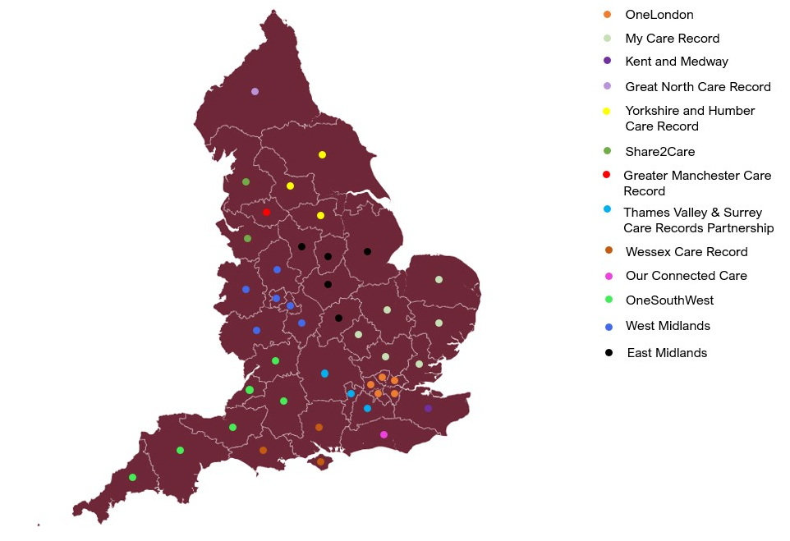

(Map adapted from https://www.kingsfund.org.uk/publications/integrated-care-systems-explained)

In our research we have spoken to teams from the following Shared Care Records:

* Cheshire and Merseyside (part of the Share2Care)
* Connecting Care (part of OneSouthWest)
* SIDeR (part of OneSouthWest)
* Devon Shared Care Record (part of OneSouthWest)
* Dorset Care Record (part of the Wessex Care Record)
* Cambridge and Peterborough (part of My Care Record)
* OneLondon
* Great North Care Record
* Our Connected Care

### **Stages of development**

Each of the Shared Care Record teams that we have spoken to are at various stages of development. Some are up and running and have been for several years, others are still being built. Even those that are well established do not see themselves as the ‘finished product.’ They are continuing to expand to include further health or social care settings and developing the sharing of records within their region.

Most of the Shared Care Records that we have spoken to are used solely for direct care. The advantages of this are that the IG (Information Governance) arrangements for direct care are more straightforward.

* *"it's specifically and deliberately for direct care only, it's not for secondary use for population health or risk stratification or other means" C42*

Many regions took a phased approach focusing on settings identified as “low hanging fruits,” which might all be using the same clinical system.

* *“We're having a phased approach, so the low hanging fruits in the first phase and then we're dealing with, basically, the acutes and the local authorities in our second phase. (…) the lion share of all our data is coming off TPP in the first phase with a bit of EMIS thrown in.” C50*

Secondary uses of anonymous or pseudonymised data is often seen as a second step. The collected data can then be used in population health planning and research. We learned of some areas, who are beginning to use this data for these purposes, but we currently do not have information around specific improvements made with the data.

Local and national integration remains a challenge. According to one of the local ShCR team, the fact that the neighbouring regions are using the same system, in this case, Orion, would not mean that sharing and integrating their data would be any easier from a technical perspective.

## **Suppliers**

There are 5 main suppliers currently delivering local Shared Care Record systems in England:

* Orion Health Global
* Graphnet Health
* InterSystems
* Cerner
* Interweave

In addition to this, there are three - other “one-offs” – e.g., the Kainos solution in Gloucestershire.

This supplier landscape can have positive implications for Patient Encounter History if UEC (Urgent and Emergency Care) (Urgent & Emergency Care) (Urgent and Emergency Care) encounters were to be included in Shared Care Records:

* A relatively small number of suppliers who need to make changes in their systems or may have already made the necessary changes to support more advanced Shared Care Records. For example, Cerner already supports UEC encounters for OneLondon.
* Local shared care record teams will have existing relationships with systems suppliers.
* Inclusion of a detailed patient encounter history seems like a natural addition to the existing system features.

Conversely, if the key system suppliers are not willing to collaborate, introducing PEH might prove to be difficult, as there will be fewer opportunities for proving the concept. Additionally, despite a small number of shared care record suppliers who need to implement changes to their system, we would need to factor in suppliers of other UEC systems (used in ED (Emergency Department), UTC (Urgent Treatment Centres), GP (General Practice) OOH etc.) to adapt their systems to display encounter information from the shared care record system.

We already know from local shared care record teams, that working with system suppliers can be challenging:

1. Off the shelf solutions have limited adaptability meaning that responding to user needs is harder.
2. Switching between clinical systems is expensive. This creates a bias towards working with existing suppliers.
3. For some suppliers, the UK is not be the main market, meaning they are more likely to offer cookie-cutter solutions, as their incentives are limited.

Some teams have encountered challenges with using existing products:

* *“Despite the fact that all these wonderful capabilities were advertised by [a supplier] at the time that they were being considered, as soon as we announced them as a preferred supplier, all of a sudden, they weren't quite as able to do things as they had first told us” C50*

Some regions decided to build their own shared care record systems. The benefits named by one of the teams included:

* Keeping the key skills within the team
* Retaining control of the built system
* Being more flexible
* *“It allowed us to be more nimble, have control over it, we can grow it depending on what the users are requiring. There was already work, you know happening in [NAME], so let's bring it together unless it and it keeps the skills in science, [NAME], in their nature and their social care environment. So, as we grow, we kind of just, you know, we're not relying on others.” C65*

## **System architecture**

There is no standard implementation model for shared care records; some shared care records contain a Clinical Data Repository (CDR) which provides a consolidated view of records contained within disparate clinical systems; Whereas other shared care records are built using an ‘on demand’ model with requests for data being made to clinical systems in real-time.

Most of the Shared Care Records have been built using the ‘on demand’ information flow model.

* *“Our stated intention has always been to try and use on-demand access as much as we can and use API driven approaches where possible, most of the Shared Care Record is not expected to be persisted.” C50*

This does add complexity for any national or regional systems needing to integrate with Shared Care Records as a consistent solution will be required irrespective of the underlying implementations of Shared Care Records.

The FHIR (Fast Healthcare Interoperability Resources) standard is used across all Shared Care Records and the expectation would be that FHIR would be used for integration between national, regional systems and shared care record systems.

* *"Well, I suppose the first way is we've adopted open standards. So, we've adopted FHIR as the underlying technology and cloud-based N3 accredited storage as the architecture for how we deliver our shared care record." C42*

However, some teams reported challenges with adopting the FHIR standard due to supplier capabilities.

* *“In terms of linking up to the Orion platform, Orion, again during the procurement they claimed to be able to work with FHIR, but it became quite clear that they couldn’t, and they need to develop all these capabilities.” C5*

It is also worth noting that at the moment, 111 telephony and 111 online, use ITK standard for PEM messages.

Other pain points are related to the use of standards:

* *“a lot of the other shared record capabilities are built on an interpretation of those standards, (…) and what we found was as we were trying to connect (…) those who claimed they did have that ability to connect via open source actually couldn't even deliver a basic HL 7 message to the system.” C55*

For PEH the expectation is that standards for the sharing of encounter data would be created to avoid requirements for shared care records to have to interpret the FHIR standard. This will be required to ensure interoperability across all relevant systems can be achieved.

## **Data and IG**

Shared Care Records are required to establish a legal basis for sharing data. There are three levels/basis for sharing data:

1. For direct care
2. For secondary uses, e.g., using anonymised data for planning and research
3. Giving patient’s access to their data

### **Sharing for direct care is the most straightforward**

It is invariably easier to gain buy-in from stakeholders if the legal basis for sharing information is direct care. We found that consent is not a reliable basis for sharing, as it presents a hurdle to data access.

* *“We don't rely on consent - if a clinician is offering direct care, they don't have to ask for the consent” C54*
* *“In a nutshell the recommendations really were absolutely you should be joining up our information for direct care, why aren't you?” C49*
* *“And because we've deliberately kept it for direct care, it's been a much easier conversation with the stakeholders than it would have been, I suspect if we'd been looking at re-stratification, population health management and other secondary uses of that data, as well as a much more challenging conversation with our population." C42*

We have also learnt that service improvement falls under the remit of direct care.

* “[there is] a strong mandate for joining up depersonalized information for the purposes of service planning, improvement, and research.” C49

Shared Care Records have taken the following approaches to IG:

### **Individual organisations are data controllers in most cases**

Individual care settings (organisations) where the patient encounter data originates typically retain the data controller role. There are instances where the notion of "joint" data controllership exists; this can happen when the data is processed by another organisation viewing the information.

* "So, it we didn't do anything different to what we would do for any other kind of new system off or sharing locally within our own organizations. It was just on a wider and grander scale. " C59
* [Secondary Uses] "that's not to say we're not going to do it, but at that point it would be a new a new consideration in terms of again, the transparency going out to the public and putting the appropriate governance in place. " C59
* [Speaking of COPI notices] "COVID did as a lot of favours in in relation to IG." C55

It is worth noting that COPI notices (Control of patient information) allow the processing of Confidential Patient Information (CPI) for specific purposes. They have been introduced amid COVID-19 crisis to facilitate information sharing.

So far, the Secretary of State has issued four of these notices requiring NHS Digital, NHS England & Improvement, all healthcare organisations, ALBs (Arm's Length Bodies), local authorities and GPs to process CPI for the purposes related to communicable diseases.

[COPI notices](https://www.gov.uk/government/publications/coronavirus-covid-19-notification-of-data-controllers-to-share-information) have now been extended until the end of March 2022 to help give healthcare organisations and local authorities the confidence to share the data needed to respond to COVID-19. The notices will be reviewed on or before 31 March 2022 or may be extended. If no further notices are issued, the notices will expire on 31 March 2022.

Some of the participants in our Alpha research suggested that If the COPI notices are not extended beyond March 2022, it might present an IG challenge for some of the Shared Care Records teams.

### **Sharing requires data-sharing agreements between data controllers**

A data sharing agreement between the parties sending and receiving data forms a major part of compliance with the accountability principle, although it is not mandatory. Organisations might use a different title for a data sharing agreement, for example: an information sharing agreement; a data or information sharing protocol or contract; or a personal information sharing agreement. We found that individual data controllers agreed on a data sharing agreement as a prerequisite to sharing information.

* *“Information sharing agreements and DPIA's are in place between the 5 ICS's” C54*
* *“GPs have to sign the PISA and DISC” C51*
* *"In order to share data, you have to establish legal basis and that that legal basis has to be a part of legislation. And so, we have." C53*

It is likely that a solution for PEH data will require a data sharing agreement with all shared care records. Establishing these agreements can be time consuming. However, this will be true regardless of whether Shared Care Records is the delivery mechanism or not.

### Role based access across Shared Care Records have different approaches

Most Shared Care Records handled the question about who can access personal and confidential patient data by implementing RBAC (role-based access), but took different approaches to establishing roles:

* *“[we have] Only 2 different access - care professional and admin”* C53
* “Roles based access for data - in a consistent way across London” C49

## **User Experience**

Shared Care Records have been appreciated by the clinicians. Note the research into Shared Care Records has been aimed to get a broad understanding of the programme, rather than specific usability insights.

### I**n context launch and viewing patient encounters in one system.**

The ultimate aim for the Shared Care Record is to have one place for clinicians to view their patients’ information. Clinicians will still update their host systems to record the patient interaction but ideally be able to view the record from that system. When the information is not stored within the host system, a function called in-context launch allows clinicians to access the information from within their current system.

We have heard that there are some cases where web browser access is necessary, for example, on GP home visits. We can also assume that other settings may need to access the record through a web browser such as health visitors or the ambulance service.

* *"They've got contextual launch straight into [Shared Care Record]. And it would be locked in context of that patient, so whenever they hit the button, they can only view that patient's record within [NAME]" C42*
* “So, *if we can have a like a one stop shop place to go and get in in one or many tools, and if it's one stop shop, at least we know where to sort of direct our clinicians to go and get it. So be that summary care records or share care records and then.”*

Where in context launch is not available, a clinician may need to have two systems open with two different screens. This adds to time needed to review records and has been described as a pain point. Having said that, clinicals preferred to have access to rich information even if it meant opening multiple systems.

Even within well-developed shared care records, clinicians must look for information in multiple places.

* *“Well, I've currently logged into about 6 systems. Every time I sit down in the morning. [clinician using shared care record]” C58*
* “[I have] *two screens open, so I have the [Shared Care Record] (...) in its own URL (…) and then I can (…) keep the EMIS notes open at the same time alongside each other” C58*
* *“And so, I'll have multiple screens app and you know for all those systems that I've talked about, which isn't ideal.” C60*

### Showing encounters

Across the regions, the emphasis on encounters as key information differs and there are various ways encounters are shown:

* each setting having a separate section showing encounters
* all encounters shown together
* users choosing what to view
* *“In terms of how encounters information is presented then I have genuinely heard different views. Some people like to see all encounters combined – i.e., a single ‘list’ (…) but I have heard people saying they like to see things separated – and to know that “this list is GP encounters; this list is hospital encounters” (..) I think probably the best way is the ability to sift and sort from a single ‘list,’ so flexible approach.” C48*

Many areas are displaying the encounters sorted by care settings. For example, GP encounters will be grouped together and separate from encounters that occurred in other care settings.

The screenshot below shows encounters from primary care and community settings, grouped separately.

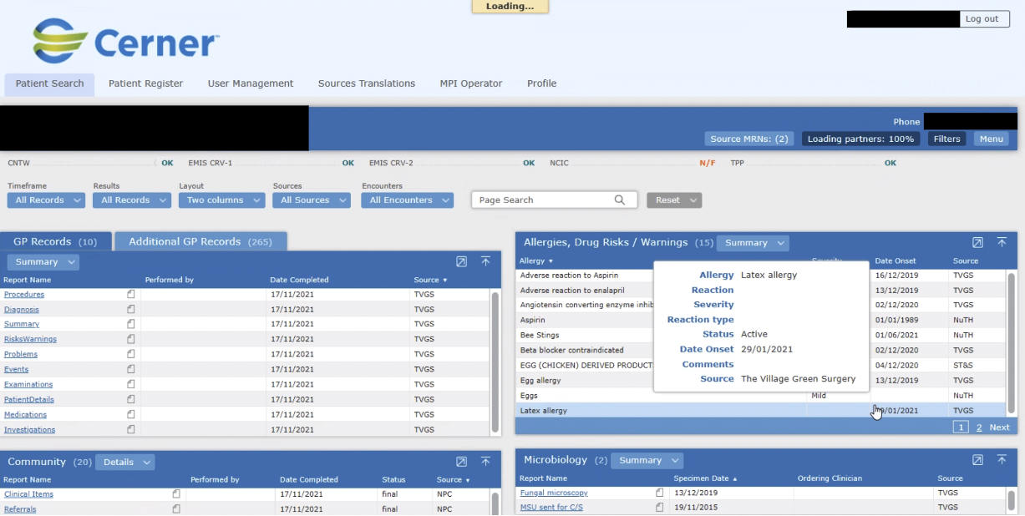

The image below shows a dashboard view for Connecting Care, a Shared Care Record based in Bristol. This view includes encounters under “All Events & Appointments,” which can be filtered and viewed by the care setting (e.g., GP, hospital, community care).

The dashboard also includes two alerting sections, for COVID risk and for safeguarding.

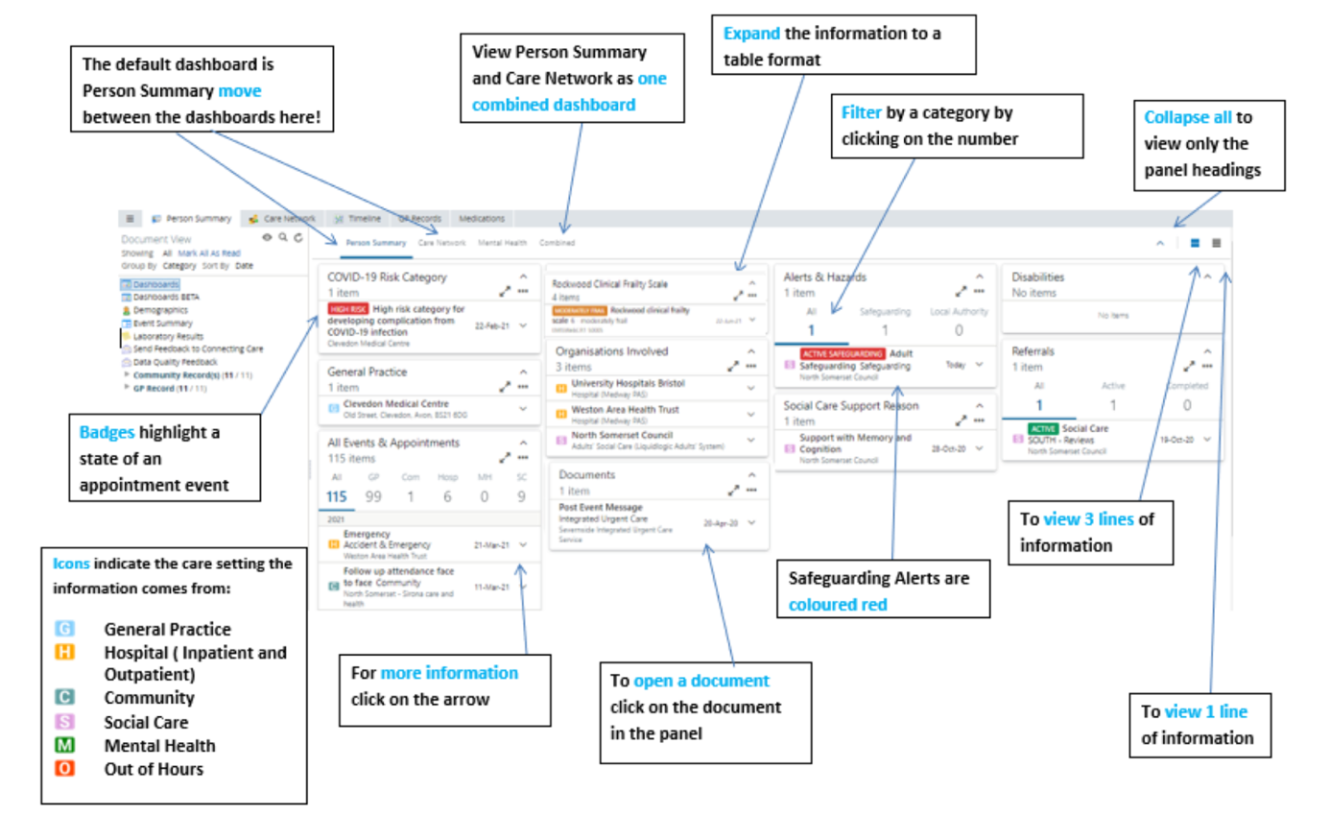

Two of the regions we have spoken to have highlighted use of a timeline view. This is when the encounters from different care settings are displayed chronologically in a visual manner.

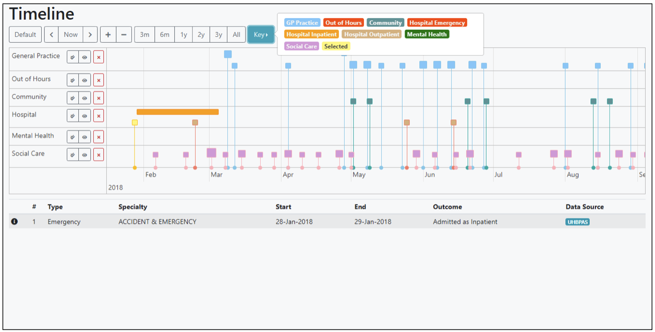

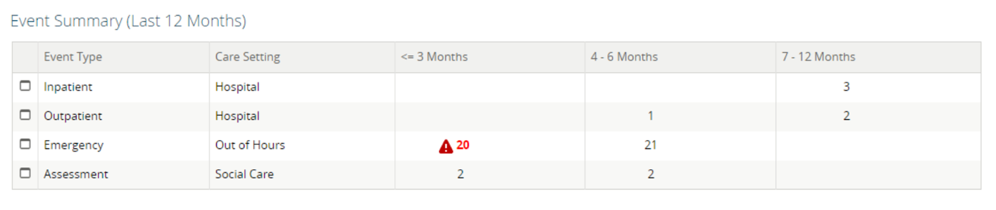

Encounters can be called different things in different settings and system. There is not a common language even across similar settings e.g. Two trusts might be using different terminology

* Encounters
* Events
* Appointments

### **Tailored view of patient information**

Multiple ShCR teams reported the importance of tailored record views, quoting needs in different settings or personal preference:

1) care settings determine the information needs

For example, an ambulance crew need a one-page summary of most pertinent patient information which will be easy to read and act on in a high-pace emergency environment, whilst a specialist consultant might need more detailed information.

* *“[talking about ambulance crews being able to access the Shared Care Record].. it can be overwhelming for ambulance crew” C64*

2) different clinicians need different information

For example, a care home nurse might view medications and hospital discharge information most often, while a consultant psychologists might want more long-term records for patient history assessment.

3) clinicians have personal preferences

* [talking about a clinician’s view] *You can personalize these things. People love that.C65*

The personalisation needs would require further research. However, it is worth noting that we have also heard about this user need in relation to using clinical systems in general (rather than specifically Shared Care Records)

* *“You can customise anything in EMIS. So, I've created my own summary screen of all the things that I like to do, and then you can have little pop-ups, which you can customise.” C43*

Future patient access of encounters may require separating medical and confidential patient notes. For example, mental health and social information which is considered more private or sensitive.

* [speaking of free text] *“The free text will also provide information on other areas of concerns, sort of, high blood pressure, diabetes, those sorts of things. So, that needs to be available. However, they may also include things such as the diabetic concerned has been having an affair and came to speak to me about it and their blood pressure had rocketed as a result. That doesn't need (…) to be shared” C44*

### **Famine to feast**

A recurring theme observed in our research is that clinicians recognise how information-poor some of the care settings used to be. The settings mentioned most often included ambulances, emergency departments and out of hours services.

* *“I was looking at the Adastra screen in the after-hours environment, seeing absolutely nothing but a blank page” C58*

Clinicians had a clear preference to have access to patient information even if it meant they need to use multiple systems to build a good understanding of patient’s condition.

There are still circumstances when clinicians can expect little to none patient information:

* Healthcare of those who have been deregistered from their GP surgery
* Healthcare of prisoners or those who have been recently released
  + *[pain point - not having information] knowing nothing about what happens to patients? Health care in a prison environment? If you don't know those things, you simply can't make a proper decision. A proper clinical decision. C58*
* Healthcare of people who are homeless

### **Access to records**

Some teams we have spoken to have highlighted some access issues when using shared care records

1. Access might be problematic outside the physical ‘base,’ for example in ambulances or during home visits. This might be due to connection issues as well as software not being developed for mobile devices
2. lacking the right device
3. issues around smartcards

* *to access some of the clinical records, you need to authenticate through verification. Inherently that's been difficult in the mobile setting that the ambulance service works in because of some of the requirements we've got round some of them, i.e., you needed. Historically, you needed to be on like [the] N3 connection. You needed a smart card. C52*
* [In London] “*(…) for example, they piloted the Shared Care Record application on the iPad with the biometrics access to kind of get around some of those smart card issues which we've drawn out in the user research as being a barrier to entry.” C52*

Our conversations have also highlighted the importance of the records being available via a browser (rather than via a host system). For example, some care homes might be using old technology, unable of launching records in context, meaning that the only away of accessing a Shared Care Record is to use a browser view.

### Examples of Shared Care Records built on user-centred design principles

Records that have been created in house, have often been built with user centred design principles at the centre. This has allowed them to adapt to their users’ needs in a more agile way.

* *“I think the reason is that you know bringing in a big company to do all this sort of stuff is fine. You know if we want to do that, but for us it allowed us to be more nimble, have control over it, we can grow it depending on what the users are requiring.” C65*

Another advantage to this approach is that an in-house team is developed which can grow and adapt as needed and reduce reliance on external services:

* *“(…) as we grow, (…) we're not relying on others.” C65*

Being able to adjust the user experience through user testing, is a further advantage of an area building their own system.

* *“I guess it's also that testing usability with stakeholders all the time.”C65*
* *“We've got one of our senior clinicians that brought in to try and embed clinical safety into the design of these things as we kind of grow it.”C65*
* *[talking about feeding into Shared Care Record design] “So I have contributed to the user interface in [NAME}, but it tends to be at the end.” C60*

## **Public perception and consultation**

All regions have conducted public consultation around the regional shared care records with the option for members of the public to opt out of the shared care record. These consultations aimed to highlight the way the regions were to share data in a safe and secure way, enabling improved quality of care and improving services. The way these consultations took place varied but the aim was to dispel any common misconceptions, answer questions and gain the public’s view on the sharing and access of their data. During our research, some teams reported an average patient opt out rate to be around 1%.

* *"I think people have been won over and those stigmas have been busted. It's proven that, actually, we're able to provide better care experience for our patients, because we can see that information, rather than compromising their confidentially or otherwise, because, you know, it's only open for direct care." C42*
* *“That [public consultation] really recognised that actually people were really happy for their information to be shared for the purposes of direct care and were really shocked that hadn't already been done.” C49*

OneLondon has published their [Citizen Summit](https://onelondon.online/citizenssummit/) online allowing for a wider audience to view public perceptions and in order to “enable policies for joining up people’s health and care data in a way that is legitimate and continues to build trust and confidence.”

A similar approach to encounter information would ensure data sharing is patient led, and de-risk establishing data sharing agreements. This would also avoid any negative connotations about data sharing at a national level as the mandate comes from representative patient groups.

## **Shared Care Records are already making a difference**

Our research has highlighted several areas where well-established shared care records are already having a positive impact on patients and the way clinicians work. The quotes below, from regional case studies, draw out how having encounter data within the records have allowed clinicians to be more time efficient, cost efficient and reduced the stress on other services:

[One London Case studies](https://www.onelondon.online/wp-content/uploads/2020/10/Case-studies-joining-up-information-for-direct-care.pdf)

Reduction in A&E attendance:

* *“A lady in her 70s had been experiencing dizziness and came in to see me. A couple of days before she had had a fall and been taken to A&E. During a scan she had overheard the hospital staff say something about a bleed. When I heard this, I became concerned as the patient had suffered a stroke the previous year. Ordinarily, I would have recommended that she return to A&E to ensure that everything was ok. However, access to the London Care Record meant I could see the hospital notes straight away. This confirmed that the brain bleed she’d had previously had in fact successfully healed. It meant I could provide reassurance to the patient there and then, and saved her reattending at A&E.” GP, Tower Hamlets*

Effective prioritisation of resources and reduction in non-elective admissions:

* *“I assessed a breathless patient over the phone who had significant palpitations and presyncope. I was almost certainly going to arrange an ambulance but then on accessing the London Care Record it came to light he had a background of anxiety and was on propranolol. He hadn’t taken his medication that morning. I advised him to take it. I eventually called the patient back to reassess and he was symptom free. I was able to give him the best support and treatment and freed up an ambulance to treat patients elsewhere.”* Advanced Clinical Practitioner, Southeast London

[Connecting Care – different perspectives](https://orionhealth.com/uk/knowledge-hub/case-studies/connecting-care-different-perspectives/)

When a patient can’t fully communicate recent medical history:

* *“I’ve found Connecting Care helpful especially when a patient does not declare all of their mental health history, but their symptoms are complex. It’s also been useful when a patient seems confused, but I can’t get to the bottom of whether it is mental illness or dementia. It wouldn’t change the pathway I’d use, as we are assessing symptoms and not a diagnosis and we can only assess what we know or has been declared, but it has been reassuring on occasions to confirm that my instinct has been correct.” Clinical Advisor, Care UK 111*
* *“We find Connecting Care extremely useful...especially useful with emergency admissions of elderly patients who are often unable to give us the information themselves.” Consultant Orthogeriatrician, North Bristol Trust*

## Challenges with Shared Care Records in the context of Patient Encounter History

## **Data gaps**

Every region we have spoken to have pointed out the data gaps in their Shared Care Record. This is a result of certain systems or care settings being difficult to integrate or simply prioritisation.

It is worth noting that where the data gaps are is inconsistent across the country and depends on the local circumstances. Of those that we spoke to, only OneLondon include 111 telephony encounters.

* *"we're not able to see Adastra of 111 and out of hours as part of the shared care record, currently, however, the post-event message from 111 and out of hours would flow into the GP record, which in turn, would then be visible as a touchpoint either with 111." C42*
* *“Patient going to ED: start a clinical record, arrive at ED and ED team has access to a portal they can see the notes from handover - this can be a completed record or next to nothing.”*

We also understand that some information might be difficult to share. This is usually related to the sensitivity of the information. For example, children's social care data has been named as more difficult to access and needing additional consideration in the space of information governance. Children's social care information is sometimes stored in a system separate from the adult data, meaning Shared Care Record teams have an additional system to integrate.

Additionally, in a later stage of Shared Care Record development, when patients would be given access to records, it might be challenging to present children's safeguarding information, as it might include notes referencing parents who will be given access.

* *local authority (...) they'll have a system for adult social care, they'll have another system for children's social care. C49*
* *If they have to send someone to a place [when a] child bumped head, it’s helpful to know why people are under a child/health protection plan IE is it their parents etc*

Data being unstructured creates challenges for information presentation.

* *“if the data is structured it will fall into the right section e.g., allergies (…) [however, some data, for example] mental health data is not structured” C64*

Inconsistent data means that if we use Shared Care Records for encounter history, we might be showing clinicians an incomplete picture, extend time needed for clinical review and potentially contribute to clinical risk.

### **Maturity and Digital inequality**

To enable a full picture of a patient, many settings need to feed their data into the shared care record. We have learned that some settings rely on older systems.

* *" There was some obviously data maturity issues and lack of digitalization completely in some systems "C55*

These have posed problems when attempting to link services using FHIR standards. Some teams have used this as a stimulus to reduce digital inequality across the region by making sure everyone could deliver on the minimum standard. One area discussed their implementation of a ‘minimum viable data set’ as a starting point at which all sites could contribute to with the aim of *“bringing everyone up together” (C55)*

We would propose taking a similar approach when developing a national solution based on shared care records.

### **Awareness and adoption of the program**

There is a change dimension - people who may be used to working in a certain way (with no information / no shared care records) may need to change how they work. And that is hard! So, the question is how can the use of a shared care record be easily integrated into their daily practice?

Training junior doctors to use clinical systems is difficult. Once they have learnt one system, they move on rotation, often to a new system. Having a separate interface to learn on top of that each time can be too much in a pressured environment sometimes staff will say “I don’t have time.”

GPs already have a very rich source of data so adoption of the Shared Care Record by primary care GPs is more difficult. But those who have taken it on are finding the benefits of the wider information and a realisation of the data gaps within their own rich, records:

* *[GPs having already rich data] “Yes. I think it ignores the fact that there's a bunch of stuff that they probably don't know. Very often local authority stuff, what's happening with children in care and so on. But I have worked a lot with GPs that worked out of hours, that worked in homeless, that were working in urgent care settings, and they said that as soon as they started to do that their entire worldview changed, and they just realised how important it was to actually understand more about what was going on.” (C48)*

### **Encounter information is dispersed across multiple screens/tabs in the shared care record.**

Even with well-developed shared care records, clinicians still have to look for information in multiple places. Shared Care Records have been developed based on regional needs (for example, when population is experiencing high numbers of diabetes the ShCR might have prioritised the care settings providing this type of patient information). This means that some systems and settings were integrated first, and some were deprioritised in the initial development. This indicates that the experience of using Shared Care Record will be different for clinicians across the country.

The differences in the local data landscape also mean that the data collected (its type, quality, and format) differs across the regions. The PRSB (Professional Record Standards Body) standard has been used as a benchmark for some teams but has not been enforced nationally. More recently, shared care records have been assessing themselves against the PRSB core information standards.

If patient encounter history were to be introduced, an element of standardisation would be needed to define minimum data which would have to be collected and stored.

### **Challenges scaling up**

The local and national integration remains a challenge for now and for the future. Some Share Care Records have told us that using the same system, for example Orion, might not mean that integrating their data with neighbouring regions, using the same system, will be easier.

### **Systems not handling documents well**

Multiple teams have fed back that existing systems struggle to receive and display documents.

* *“I know that many people who are developing approaches to sharing records work on the assumption that the low hanging fruit is the documents. But actually, paradoxically, that may not be the case for us.” C50*

## **Viability of using Shared Care Records for Patient Encounter History**

### **Advantages**

* Shared Care Records is an existing programme with a good awareness and some level of regional cooperation which makes it a good fit for Patient Encounter History (PEH).
* Introducing PEH as part of Shared Care Record would make encounters available in the systems clinicians are already using and could eventually provide a regional or national consolidated view.
* Shared Care Record programme is already tasked to solve the challenge of sharing clinical data across supplier and geographical boundaries, with some regions having made progress in this space.
* Because the Shared Care Records are focused on patient data already, using it to solve Patient Encounter History needs would mean we do so without increasing the number of systems clinicians have to use — a key user need from the PEH Discovery.
* We can target roll out starting with Shared Care Record teams and suppliers who recognise the need for PEH and are able to prioritise it. This would lead to better engagement and simpler delivery. It would be easier to implement PEH in one region and follow with a national roll out.

### **Disadvantages**

* Existing direction for Shared Care Record teams was to deliver the programme on the local level. The national integration is an ambition but has not been an agreed deliverable yet. There is no agreed timeframe known to us.
* Regional approach might mean the national roll-out would take longer to complete.
* It is currently unclear how simple would it be to introduce PEH to existing Shared Care Records in a user-centred way, however user-centred design practices have been evidenced in some Shared Care Record initiatives.
* The limited number of suppliers servicing the Shared Care Record programme means, that if the incentives for them are insufficient, we might struggle to find partners for proving the PEH concept.

### **Considerations**

* In order to prove the concept, we would have to run experiments in two types of Shared Care Record environments: a region using a CDR (clinical data repository) model and a region using registry model.
* A risk of data duplication should be considered if PEH was to be introduced to Shared Care Record. A registry model, where the data stays within the system it was created, could support mitigating this risk.
* Of those that we spoke to, only OneLondon include 111 telephony encounters.
* Introducing an additional feature to Shared Care Record would require additional training in environments where clinicians already face high time pressure.
* There is a possibility, that some regions might not be interested in prioritising PEH development over other features or integrations, however if enough regions tell us that PEH is not a priority then we should use this in consideration of the viability of the project and whether to continue.
* After PEH is implemented, national and regional systems are likely to have to continue to support existing solutions such as RCS and PEM, up to the point where all shared care records contain encounter data and have developed the national and regional systems integration.
* There is a question around governance of the PEH project and whether it makes sense for it to be governed within the national Shared Care Record programme or, as it is currently, within Urgent and Emergency Care.
* Not all settings share or are technically able to share patient encounters, meaning clinicians might not have a complete picture available to them (this will be true regardless of solution).
* System providers might need to make changes in how data is delivered (real-time vs. batch). Currently, there is no standardisation in how data is being captured and shared. Note that this will be true regardless of solution.

## Appendix

Table of shared care records and which ICSs fall under it

|  |  |  |  |
| --- | --- | --- | --- |
| ICS (Integrated Care System) | Local Care Record Programmes | Regional Shared Care Records | * = Unable to find website |
| Northeast and Humber |  |  |  |
| [Humber, Coast and Vale](https://humbercoastandvale.org.uk/) | [Yorkshire and Humber Care Record](https://yhcr.org/) | [Yorkshire and Humber Care Record](https://yhcr.org/) |  |
| [North East and North Cumbria](https://nhsjoinourjourney.org.uk/) | [GNCR](https://www.greatnorthcarerecord.org.uk/) | [GNCR](https://www.greatnorthcarerecord.org.uk/) |  |
| [South Yorkshire and Bassetlaw Integrated Care System](https://sybics.co.uk) | [Integrated Doncaster Care Record](https://www.doncasterccg.nhs.uk/wp-content/uploads/2017/12/Sharing-Caring-Leaflet-v2-12.pdf) | [Yorkshire and Humber Care Record](https://yhcr.org/) |  |
| [West Yorkshire and Harrogate Health and Care Partnership](https://www.wyhpartnership.co.uk/) | [Leeds Shared Care Record](https://www.leedscarerecord.org/) | [Yorkshire and Humber Care Record](https://yhcr.org/) |  |
|  |  |  |  |
| Northwest |  |  |  |
| [Cheshire and Merseyside Health and Care Partnership](https://www.cheshireandmerseysidepartnership.co.uk/) | [Share2Care](https://www.share2care.nhs.uk/) | [Share2Care](https://www.share2care.nhs.uk/) |  |
| [Greater Manchester Health and Social Care Partnership](https://www.gmhsc.org.uk/) | [GMCR](https://www.mhcc.nhs.uk/yourhealth/the-greater-manchester-care-record/) | [GMCR](https://www.mhcc.nhs.uk/yourhealth/the-greater-manchester-care-record/) |  |
| [Lancashire and South Cumbria](https://www.healthierlsc.co.uk/) | [Share2Care](https://www.share2care.nhs.uk/) | [Share2Care](https://www.share2care.nhs.uk/) |  |
|  |  |  |  |
| Midlands |  |  |  |
| [Coventry and Warwickshire](http://www.happyhealthylives.uk/) | [Integrated Care Record](https://www.happyhealthylives.uk/integrated-care-record/) | West Midlands | * |
| [Herefordshire and Worcestershire](https://www.hacw.nhs.uk/sustainability-and-transformation-partnership) | [Shared Care Record](https://www.hacw.nhs.uk/sharedcarerecord) | West Midlands | * |
| [Joined up care Derbyshire](https://www.joinedupcarederbyshire.co.uk/) | [Derbyshire Shared Care Record](https://joinedupcarederbyshire.co.uk/about/our-work/derbyshire-shared-care-records) | East Midlands | * |
| [Leicester, Leicestershire and Rutland](https://www.leicestercityccg.nhs.uk/about-us/local-sustainability-transformation-plans-stp/) | [Better Care Together](http://www.bettercareleicester.nhs.uk/EasysiteWeb/getresource.axd?AssetID=66273) | East Midlands | * |
| [Lincolnshire](https://www.lincolnshire.nhs.uk/together) | [Lincolnshire Health and Care](https://www.intersystems.com/wp-content/uploads/Lincolnshire_Integrated_Care_Portal.pdf) | East Midlands | * |
| [Live Healthy Live Happy Birmingham and Solihull](https://www.livehealthylivehappy.org.uk/) | [Birmingham and Solihull Shared Care Record](https://www.livehealthylivehappy.org.uk/birmingham-and-solihull-shared-care-record/) | West Midlands | * |
| [Northamptonshire Health and Care Partnership](https://northamptonshirehcp.co.uk/) | [Northamptonshire Care Record](https://northamptonshirehcp.co.uk/ncr) | East Midlands | * |
| [Nottingham and Nottinghamshire](https://healthandcarenotts.co.uk/) | [Nottinghamshire Health and Care Portal](https://www.digitalhealth.net/2018/02/nottinghamshire-shared-care-record-live-acute/) | East Midlands | * |
| [Shropshire and Telford and Wrekin](https://stwics.org.uk/) | [One Health and Care](https://stwics.org.uk/our-priorities/one-health-and-care/how-does-one-health-and-care-work) | West Midlands | * |
| [The Black Country](http://www.healthierfutures.co.uk) | [One Health and Care](https://www.blackcountryandwestbirmccg.nhs.uk/about-us/one-health-and-care) | West Midlands | * |
| [Together we’re better – Staffordshire and Stoke-on-Trent](https://www.twbstaffsandstoke.org.uk/) | [One Health and Care](https://www.twbstaffsandstoke.org.uk/about-us/our-work/one-health-and-care) | West Midlands | * |
|  |  |  |  |
| East of England |  |  |  |
| [Bedfordshire, Luton and Milton Keynes](https://www.blmkccg.nhs.uk/about-us/blmk-ics/) | [My Care Record](https://www.mycarerecord.org.uk/) | [My Care Record](https://www.mycarerecord.org.uk/) | * |
| [Cambridgeshire and Peterborough](https://www.fitforfuture.org.uk/) | [Cambridgeshire and Peterborough Shared Care Record](https://www.cambridgeshireandpeterboroughccg.nhs.uk/health-professionals/news-and-resources/shared-care-record/faqs/) | [My Care Record](https://www.mycarerecord.org.uk/) | * |
| [Hertfordshire and West Essex](https://www.healthierfuture.org.uk/) | [Hertfordshire and West Essex Shared Care Record](Hertfordshire%20and%20West%20Essex%20Shared%20Care%20Record) | [My Care Record](https://www.mycarerecord.org.uk/) |  |
| [Mid and South Essex Health and Care Partnership](https://www.msehealthandcarepartnership.co.uk/) | [My Care Record](https://www.mycarerecord.org.uk/) | [My Care Record](https://www.mycarerecord.org.uk/) |  |
| [Norfolk and Waveney Health and Care Partnership](https://www.norfolkandwaveneypartnership.org.uk/about-us.html) | [My Care Record](https://www.mycarerecord.org.uk/) | [My Care Record](https://www.mycarerecord.org.uk/) | * |
| [Suffolk and North East Essex](https://www.sneeics.org.uk/) | [My Care Record](https://www.mycarerecord.org.uk/) | [My Care Record](https://www.mycarerecord.org.uk/) |  |
|  |  |  |  |
| Southwest |  |  |  |
| [Bath and North East Somerset, Swindon and Wiltshire](http://www.bswpartnership.nhs.uk/) | [Integrated Care Record](https://bswccg.nhs.uk/your-health/integrated-care-record) | One South West | * |
| [Cornwall and the Isles of Scilly Health and Care Partnership](https://cioshealthandcare.nhs.uk/) | [Devon and Cornwall Shared Care Record](https://blog.orionhealth.com/new-targets-accelerate-englands-shared-care-record-ambitions/) | One South West | * |
| [Healthier Together Bristol, North Somerset and South Gloucestershire](https://bnssghealthiertogether.org.uk/) | [Connecting Care](https://www.connectingcarebnssg.co.uk/what-is-connecting-care/) | One South West | * |
| [One Gloucestershire](https://www.onegloucestershire.net/) | [JUYI](https://www.juyigloucestershire.org/what-is-juyi/) | One South West | * |
| [Our Dorset](https://ourdorset.nhs.uk/) | [Dorset Care Record](https://news.dorsetcouncil.gov.uk/dorset-care-record/) | [Wessex Care Record](https://www.wessexcarerecords.org.uk/) |  |
| [Somerset](https://www.somerset.gov.uk/social-care-and-health/somersets-sustainability-and-transformation-plan/) | [SIDeR](https://www.somersetccg.nhs.uk/about-us/digital-projects/sider/) | One South West | * |
| [Together for Devon](https://www.togetherfordevon.uk/) | [Devon and Cornwall Shared Care Record](https://blog.orionhealth.com/new-targets-accelerate-englands-shared-care-record-ambitions/) | One South West | * |
|  |  |  |  |
| Southeast |  |  |  |
| [Buckinghamshire, Oxfordshire and Berkshire West](https://www.bobstp.org.uk/) | [My Care Record](https://www.buckinghamshireccg.nhs.uk/public/your-services/your-health-services/my-care-record/) | [Thames Valley and Surrey Shared Care Record](https://www.thamesvalleysurreycarerecords.net/about/where) |  |
| [Frimley Health and Care](http://www.frimleyhealthandcare.org.uk) | [Frimley health and care](https://www.frimleyhealthandcare.org.uk/living-here/shared-care-record-how-your-data-is-used/) | [Thames Valley and Surrey Shared Care Record](https://www.thamesvalleysurreycarerecords.net/about/where) |  |
| [Hampshire and the Isle of Wight](https://hiowhealthandcare.org/) | [Care and Health Information Exchange (CHIE)](https://careandhealthinformationexchange.org.uk/) | [Wessex Care Record](https://www.wessexcarerecords.org.uk/) |  |
| [Kent and Medway](https://kentandmedway.nhs.uk/) | [Kent and Medway Care Record](https://www.kentandmedwayccg.nhs.uk/about-us/who-we-are/ICS/kent-and-medway-care-record) | [Kent and Medway Care Record](https://www.kentandmedwayccg.nhs.uk/about-us/who-we-are/ICS/kent-and-medway-care-record) |  |
| [Surrey Heartlands Health and Care Partnership](http://www.surreyheartlands.uk) | [Surrey Care Record](https://www.surreyheartlands.uk/our-priorities/enablers/digital/surreycarerecord/) | [Thames Valley and Surrey Shared Care Record](https://www.thamesvalleysurreycarerecords.net/about/where) |  |
| [Sussex Health and Care Partnership](https://www.sussexhealthandcare.uk/) | [Our Connected Care](https://www.sussexhealthandcare.uk/about-us/digital/our-care-connected/) | [Our Connected Care](https://www.sussexhealthandcare.uk/about-us/digital/our-care-connected/) |  |
|  |  |  |  |
| London |  |  |  |
| [North Central London Partners in health and care](https://www.northlondonpartners.org.uk/) | [One London](https://www.onelondon.online/) | [One London](https://www.onelondon.online/) |  |
| [North East London Health and Care Partnership](http://www.northeastlondonhcp.nhs.uk) | [One London](https://www.onelondon.online/) | [One London](https://www.onelondon.online/) |  |
| [North West London](https://www.nwlondonics.nhs.uk/) | [One London](https://www.onelondon.online/) | [One London](https://www.onelondon.online/) |  |
| [Our Healthier South East London](https://www.ourhealthiersel.nhs.uk/) | [One London](https://www.onelondon.online/) | [One London](https://www.onelondon.online/) |  |
| [South West London Health and Care Partnership](https://www.swlondon.nhs.uk/) | [One London](https://www.onelondon.online/) | [One London](https://www.onelondon.online/) |  |